***List of Configuration Installed & Setup.***

1. **Install nginx and run nginx on port number 81**

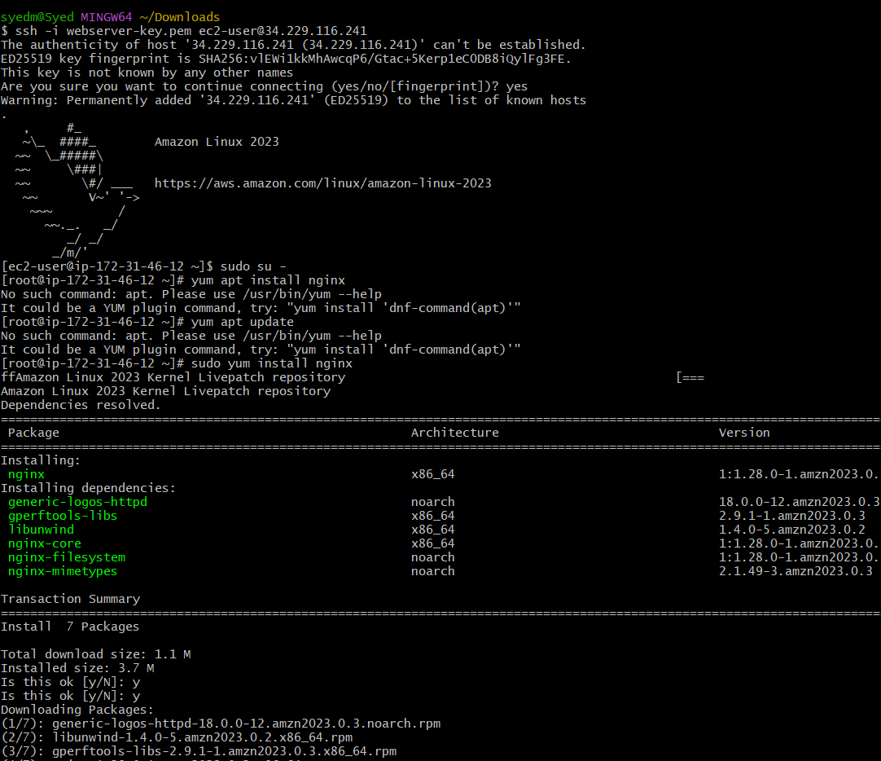

* install nginx service in linux machine : yum install nginx

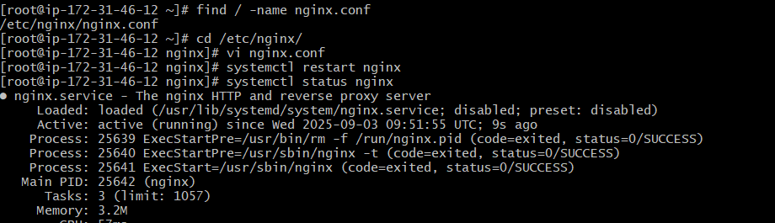

* start the nginx service : systemctl start nginx
* find the file : file / -name nginx.conf
* go to the directory : cd /etc/nginx/
* view the file contents : vi nginx.conf
* in nginx.conf change : LISTEN 80 to 81 by using ‘i’ – insert
* Enter : esc :wq! – to save and exit the file

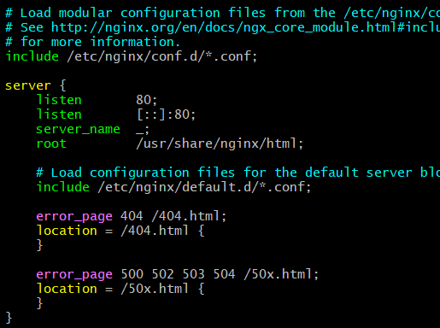

* Enter : esc :wq! – to save and exit the file
* Now got o web and enter the – “ipv 4 publicadress: 81” (note : you can get the ip v4 adress in aws instance that you have launched before)

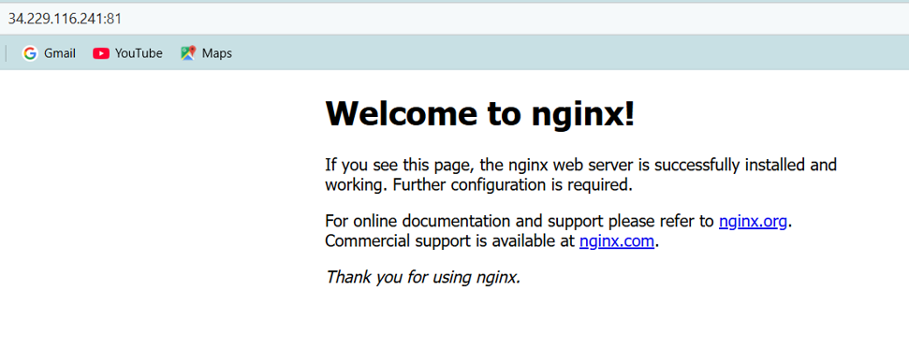

* You can see the nginx is running in port 81.

1. **Deploy a sample index.html file on nginx**

* Go to the html directory : cd /var/www/html/
* View the file : vi index.html
* Enter the text or content you want o view on web page .
* Save by entering esc button and enter :wq! – to save and exit

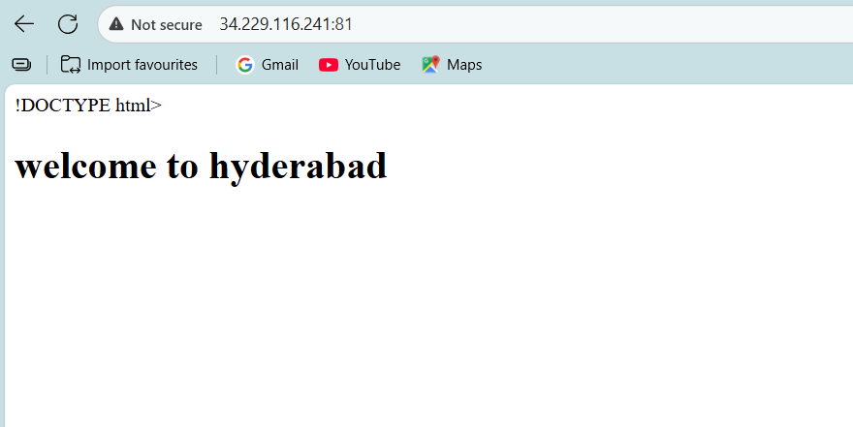

1. **Install Apache and run Apache on port number 82**

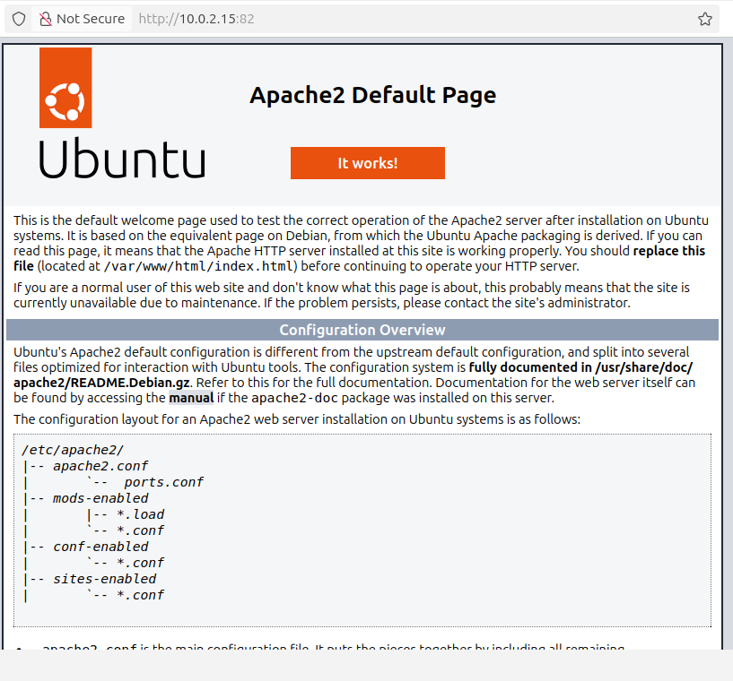  
  
**Steps Involved:**

* udo apt update
* sudo apt install apache2 : To install apache2
* sudo nano /etc/apache2/ports.conf : To change the configuration port no
* Change Listen 80 to Listen 82 port
* sudo nano /etc/apache2/sites-enabled/000-default.conf : change configuration on vbox
* <VirtualHost *:80> to <VirtualHost *:82>
* sudo systemctl restart apache2
* http://10.0.2.15:82

1. **Deploy a sample index.html file on Apache.**

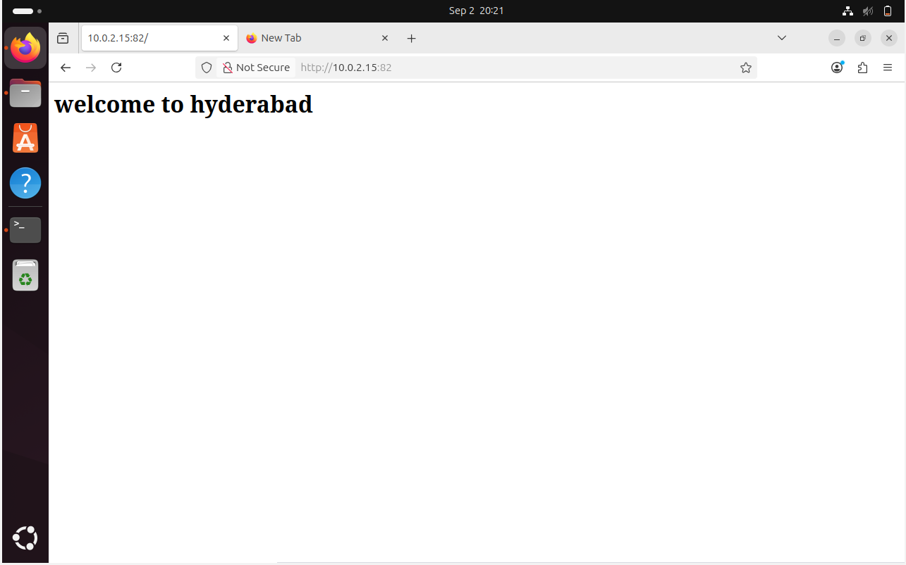

* Go to the html directory : cd /var/www/html/
* View the file : vi index.html
* Enter the text or content you want o view on web page .
* Save by entering esc button and enter :wq! – to save and exit

1. **Install Apache tomcat on port number 8082**

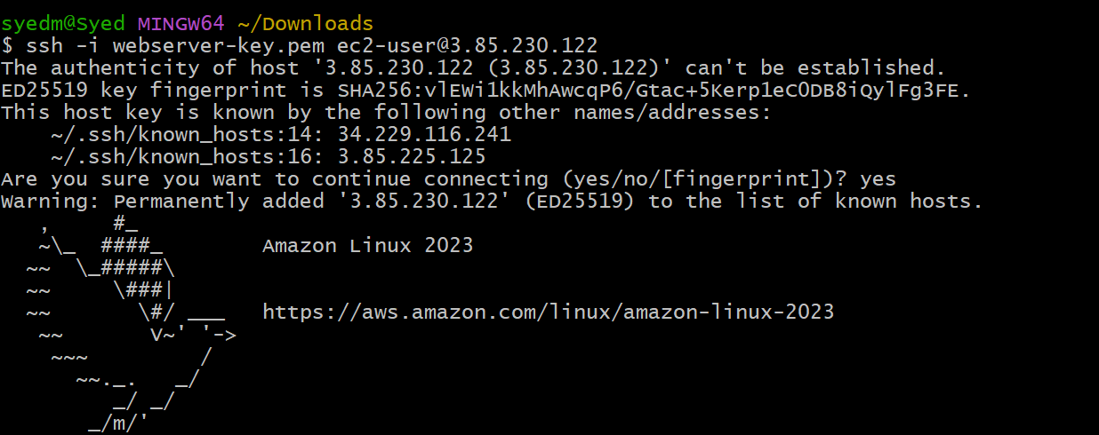

* install java : sudo yum install java -11 amazon-corretto
* download tomcat : wget <https://downloads.apache.org/tomcat/tomcat-10/v10.1.44/bin/apache-tomcat-10.1.44.tar.gz.asc>
* extract the file: tar xvf apache-tomcat-10.1.44.tar.gz.asc

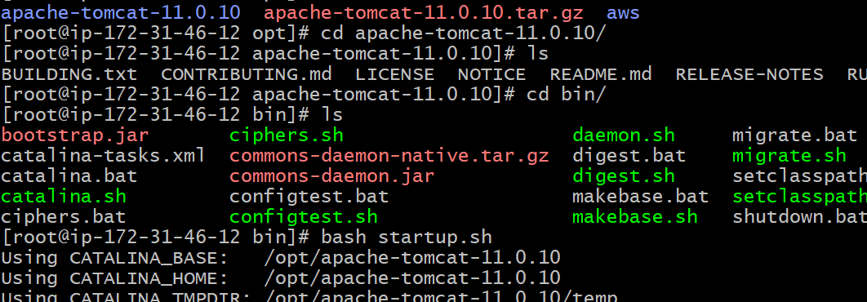

* Change the port 8080 to 8082 : /opt/apache_tomcat9/conf/server.xml

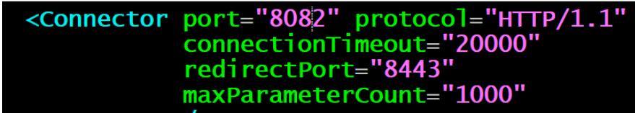

* Restart the service and enter the Ip address and the port number

https://35.174.17.167:8082

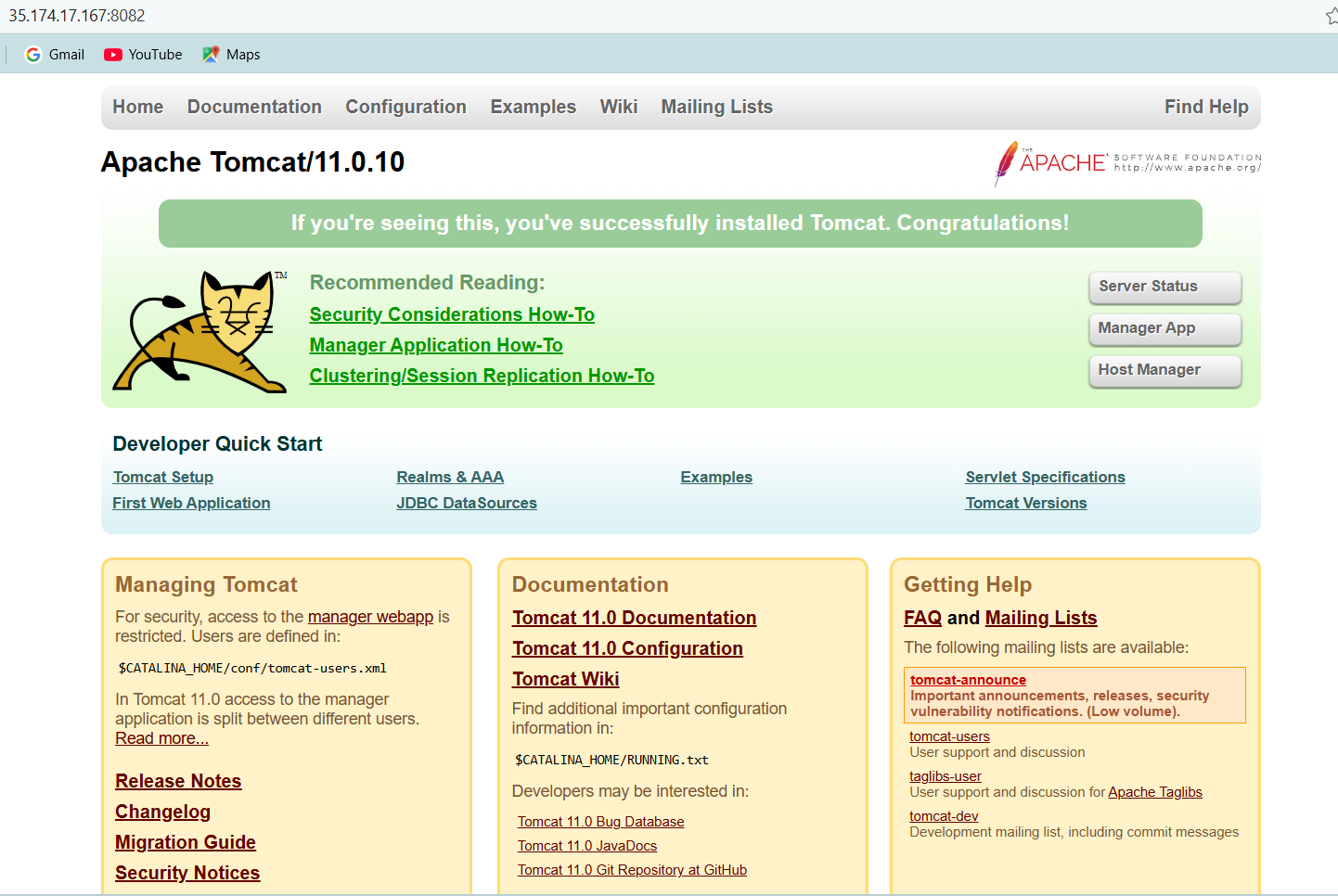

1. **Deploy a sample app on webapps**

* Goto directory /opt/apache_tomat9/webapps and download the sample war.
* Wget https://tomcat.apache.org/tomcat-0-doc/appdev/sample/sample.war



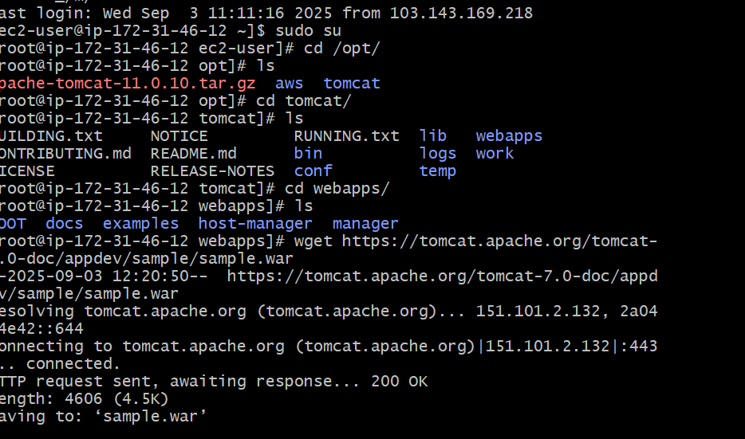

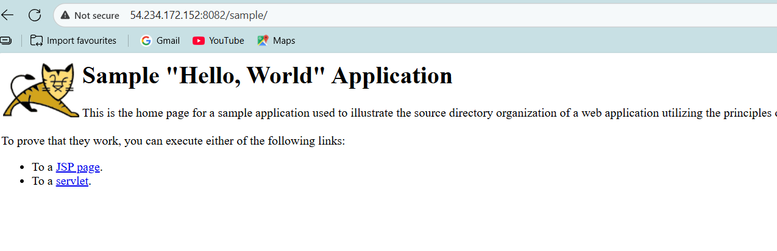

1. **Create a tomcat.service file for tomcat.**

* Download tomcat binary in /opt/:
* wget https://dlcdn.apache.org/tomcat/tomcat-11/v111.0.10/bin/apach  
  e-tomcat-11.0.10.tar.gz
* Extract/untar using tar xvf apache-tomcat-11.0.10.tar.gz and  
  rename it to tomcat11
* Then create a service file /etc/system/system/tomcat.service

Tomcat Service file:

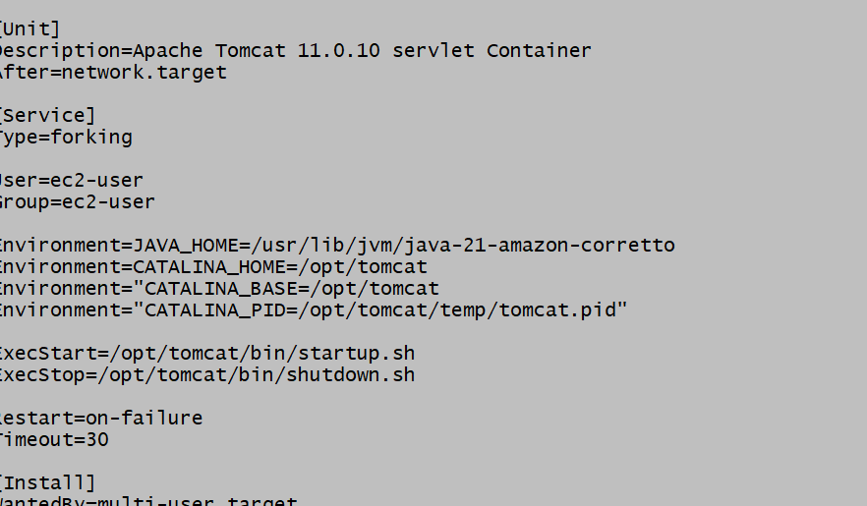

* Reload daemon status : sudo systemctl daemon reload
* Start the tomcat : ./startup.sh

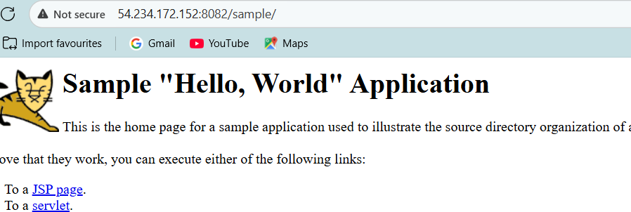

1. **Configure HA Proxy server:**

* Launch 3 ec2 instances named as:
  + 1. Server 1
    2. Server 2
    3. HA-Proxy-Server.

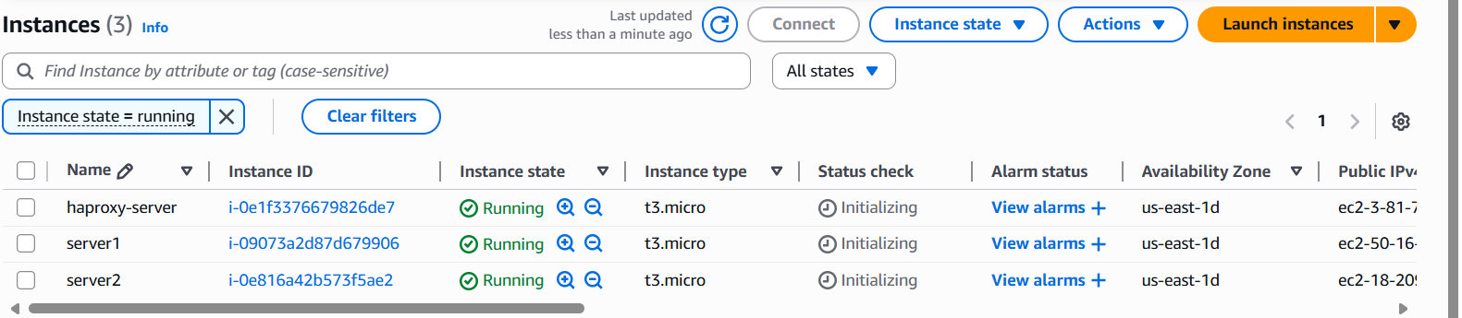

* Access the Server-1 :

Ssh -I key.pem ec2-user@public ip-server 1

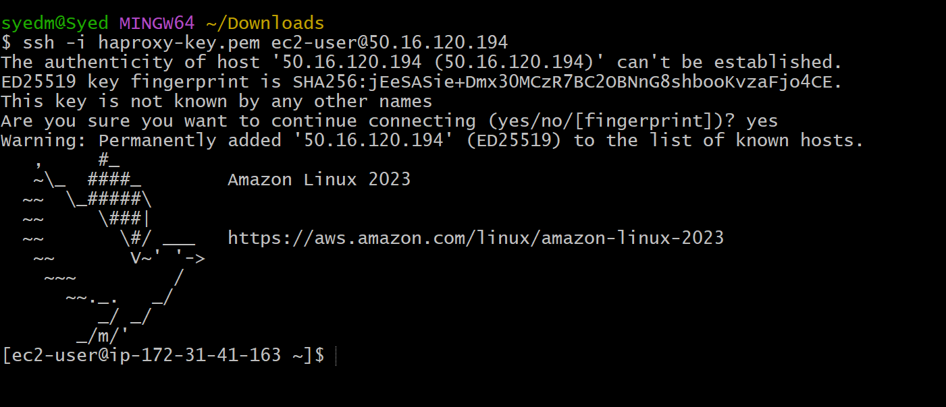

* Enter the root user : Sudo -i
* Yum update -y

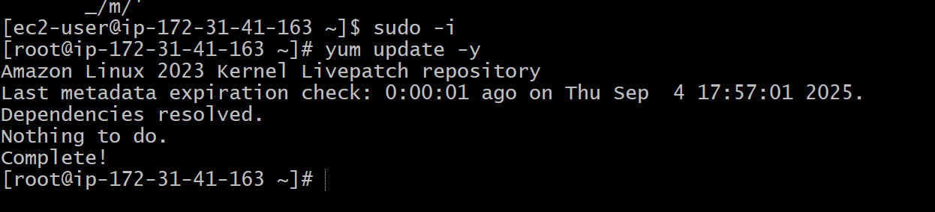

* Now, yum install httpd-y

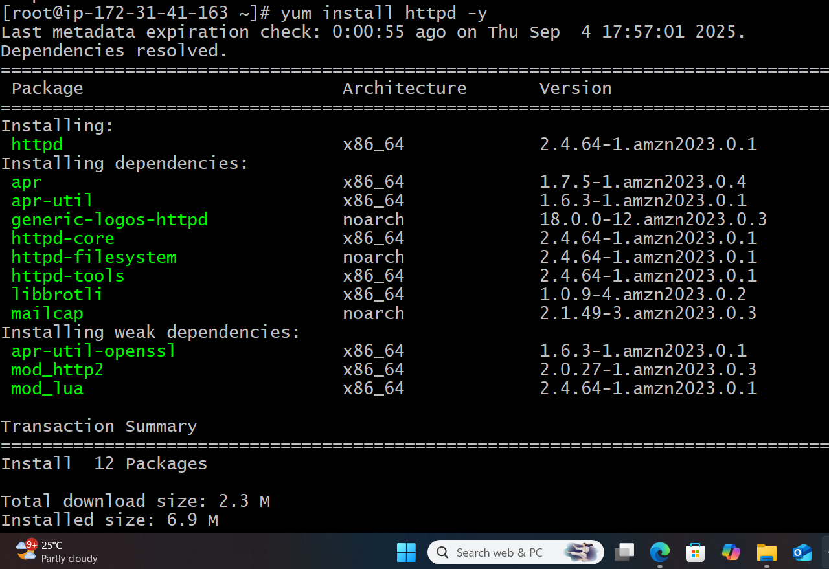

* Vi/etc/hosts
* Add HA-Proxy-Server Public IP Address



* Run, ping load balancer -c 4

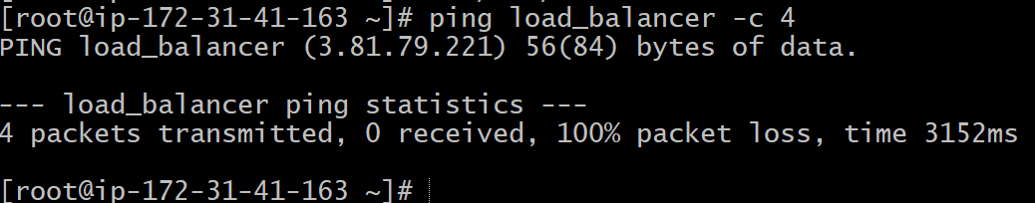

* Systemctl start httpd
* Systemctl status httpd

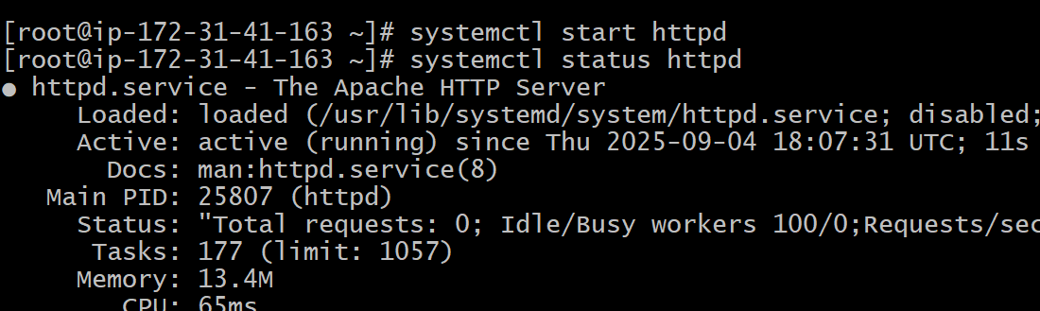

* Browse the server-1 public ip address:80 , it will work

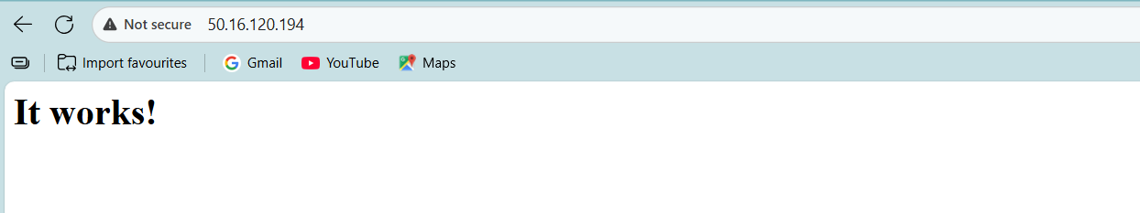

**Server -2 :**

* Connect to the server-2:

Ssh -I key.pem ec2-user@public ip of server-2

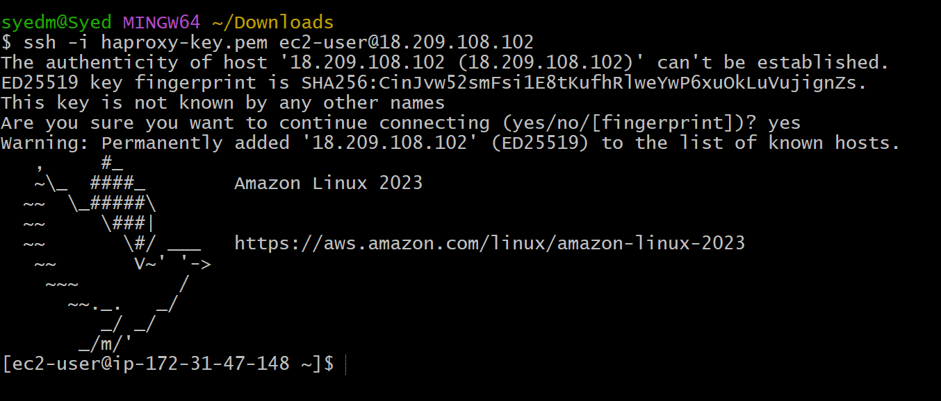

* Enter the root user : Sudo -i
* Yum update -y

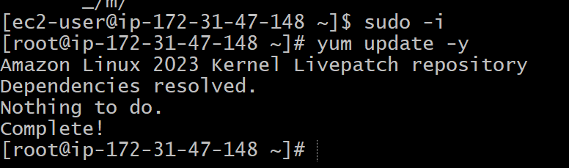

* Yum install nginx -y

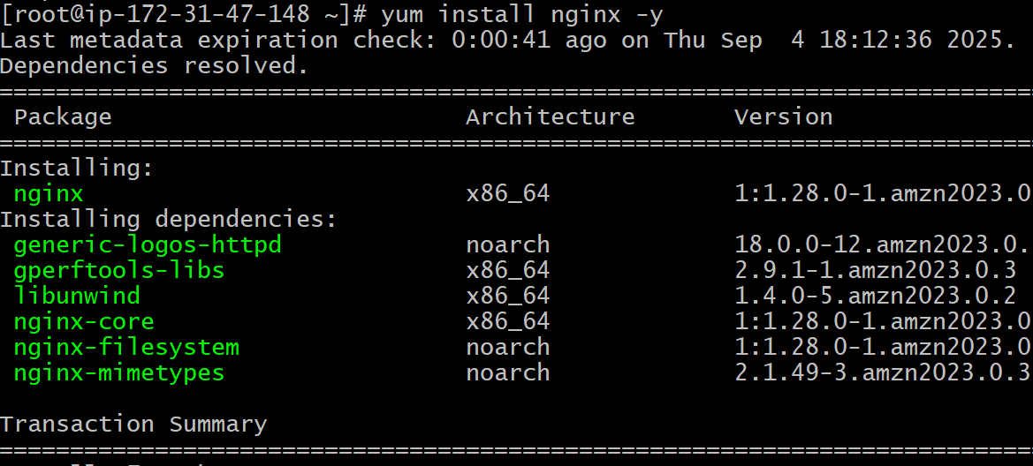

* Vi /etc/hosts
* Add HA-Proxy-server public ip address



* Run ping load balancer -c 4 on server-2

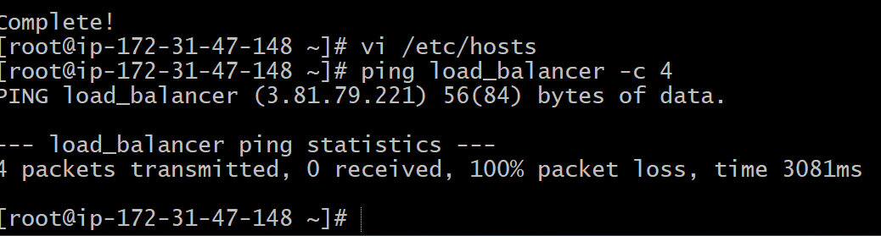

* Systemctl start nginx
* Systemctl status nginx

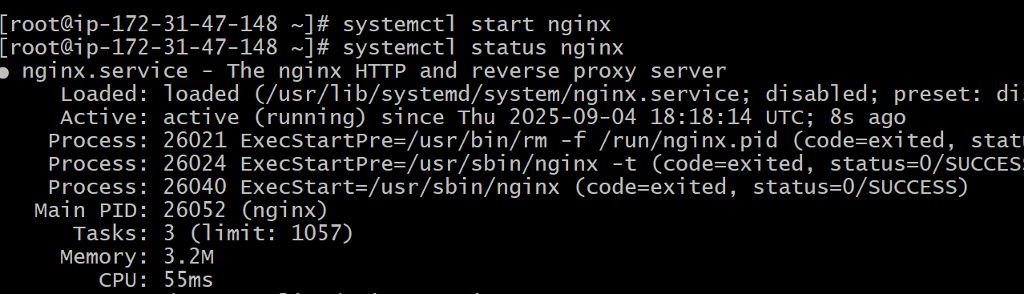

* Browse with server 2 ip address:80, it will work

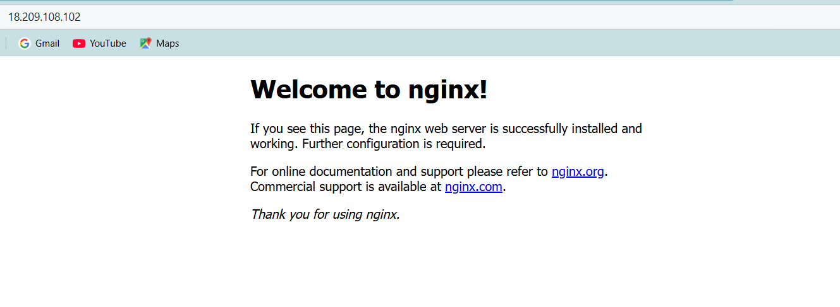

**HA-Proxy-Server Steps:**

* Connect to HA-Proxy server :

Ssh -I key.pem ec2-user@public ip of HA-Proxy-server

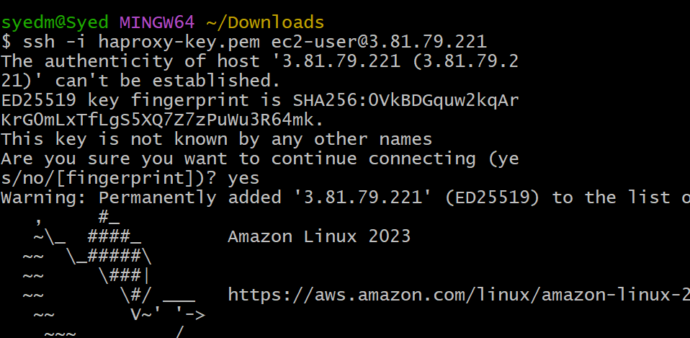

* Enter the root user : Sudo -i
* Yum update -y

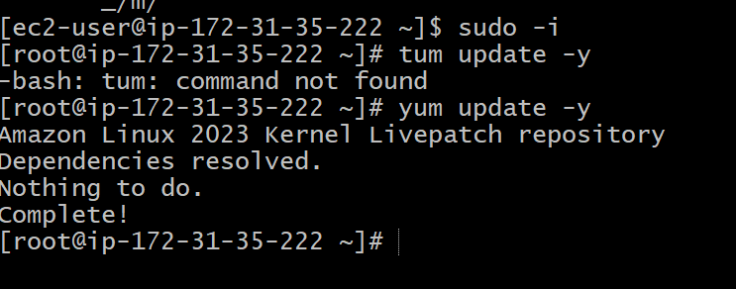

* Yum install haproxy -y

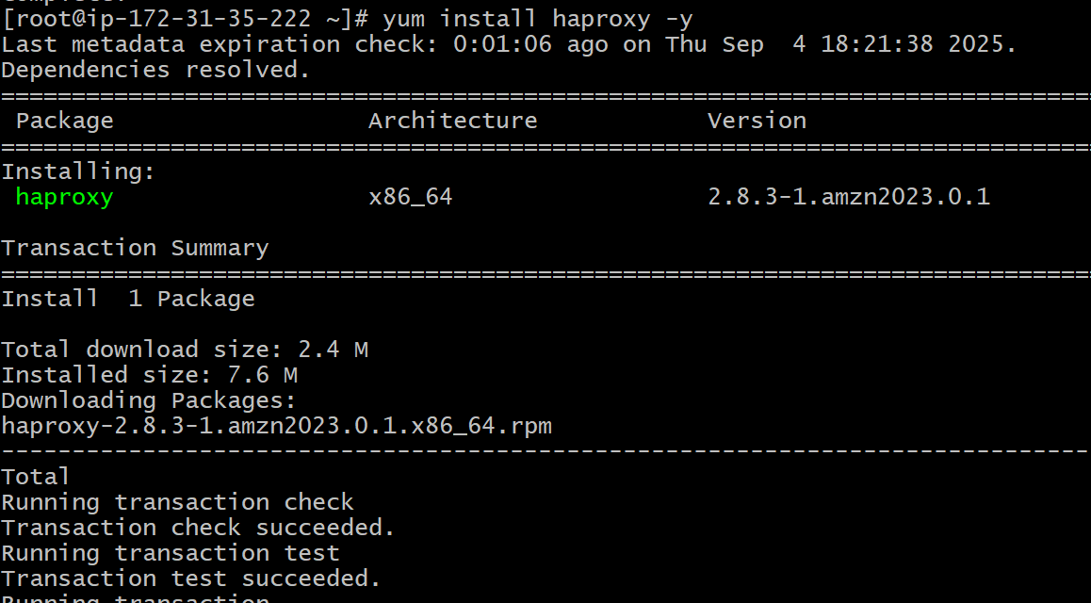

* Vi /etc/hosts
* Add Server-1, Server-2 Public ip

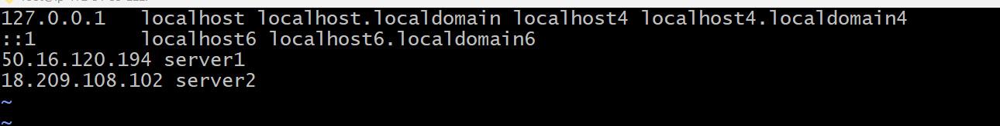

* Vi /etc/haproxy/haproxy/cfg
* Add server-1, server-2 public Ips

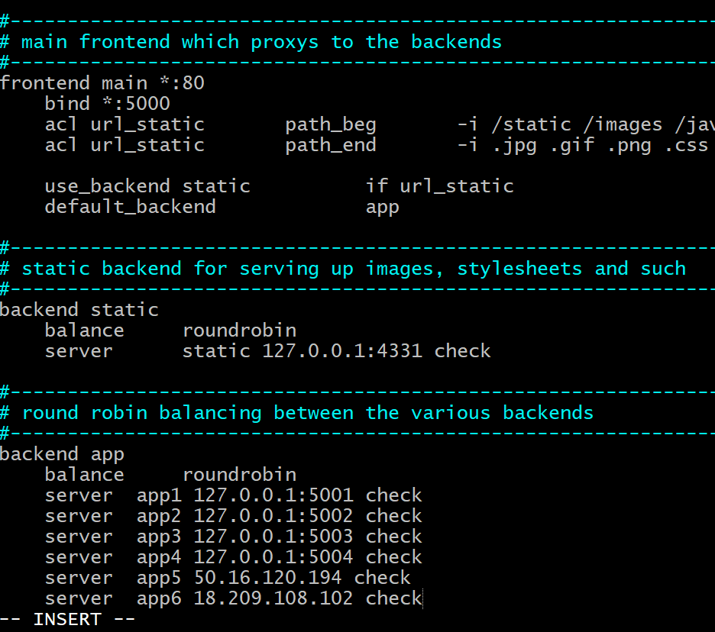

* Systemctl enable haproxy
* Systemctl start haproxy
* Systemctl status haproxy

